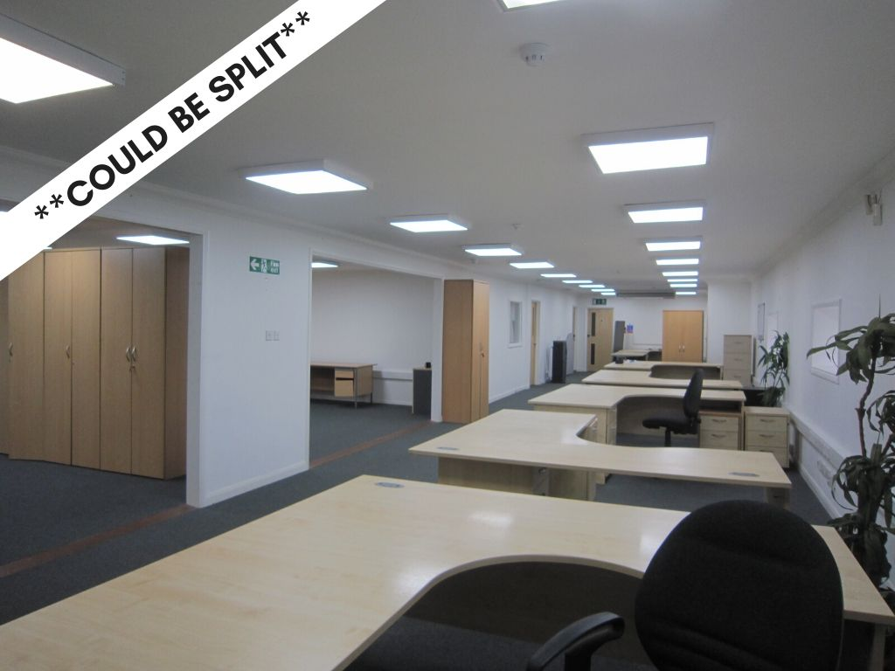

GROUND FLOOR AND FIRST FLOOR OFFICES AVAILABLE TO LET
378 m² (4072 sqft)

Including 20 Car Park Spaces
Unit 3, New Wharf
Shoreham-by-sea
West Sussex
BN43 6RN

LOCATION
Situated on the south side of the main coast road (A259) opposite Halfords. Shoreham town centre is about a 12 minute walk and the Railway Station about 10 minutes.

DESCRIPTION
The premises comprise Ground Floor and first floor offices with use of a communial kitchenette and shower/WC facilities.

The offices come with up to 20 allocated parking spaces.

ACCOMMODATION
Ground Floor 1024 sq ft 95.24 m²
First Floor 3047 sq ft 283.2 m²

- Perimeter Trunking
- Air conditioning units
- First floor LED lighting
- UPVC double glazed windows

RATES
Please refer to the Local Authority for information on rates

LEGAL FEES
Each party to be responsible for their own legal costs.

ENERGY PERFORMANCE CERTIFICATE
Energy Performance Rating E.

VAT
We understand the property has not been elected for VAT.

TERMS
New lease to be agreed based on £12 per sq ft per annum, exclusive of Rates and Service Charges. Rates: To be assessed.

VIEWING
Jim Groves Clifford Dann
Direct line: 01273 407920
jgroves@clifforddann.co.uk

In accordance with the Estate Agents (Provisions of Information) Regulations 1991 we inform you that a Member of this firm has an interest in the freehold of this property.Neither the Lessor nor the Agents gives or implies any warranty that the premises are fit for any particular use or that they comply with any relevant regulation or statutory requirement. The agents have not tested any apparatus, equipment, fittings or services so cannot verify that they are in working order. The tenant is advised to obtain verification from their Solicitor or Surveyor before proceeding.

CODE OF PRACTICE ON COMMERCIAL LEASES
Please be aware that the Code of Practice on Commercial Leases in England and Wales recommends you seek professional advice from a qualified surveyor, solicitor or licensed conveyancer before entering into or signing a business tenancy or lease agreement. The Code is available through professional institutions and trade associations or through the website www.commercialleasecodeew.co.uk

