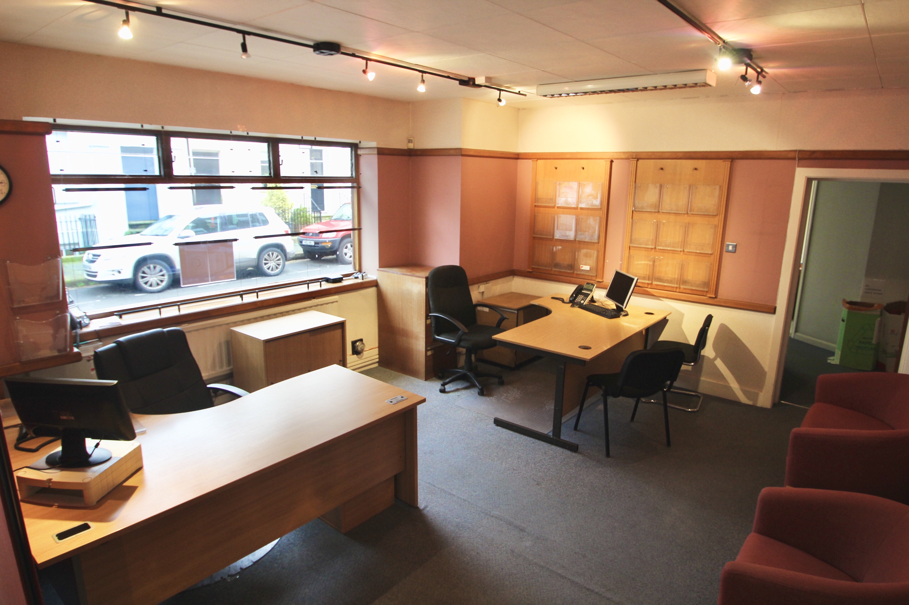

Albion House
Albion Street
Lewes
East Sussex, BN7 2NF
GROUND FLOOR SALES AREA/OFFICE AVAILABLE TO LET
21.38 m² (230 sqft) / 65.56 m² (705 sqft)
Including 2 Car Park Spaces

*Can be let seperately*

LOCATION
Lewes, the County town of East Sussex, is located 8 miles to the north-east of Brighton at the junction of the A26 and A27. The town has dual carriageway links to the M23 and a mainline railway station to London Victoria (65 minutes approx) as well as comprehensive bus services. The property stands in the School Hill area of the High Street on the corner of Albion Street and is within a short walk of the main shopping area.

DESCRIPTION
The premises comprise Ground Floor offices/sales area with use of a kitchenette and lift. Lease inclusive of service charge, exclusive of rates.

The office comes with two allocated parking spaces.

ACCOMMODATION
Office 5 230 sq ft 21.38 m²
Office/Store 4 62 sq ft 5.78 m²
Office 1 413.5 sq ft 38.4 m²

** Can be let separately **
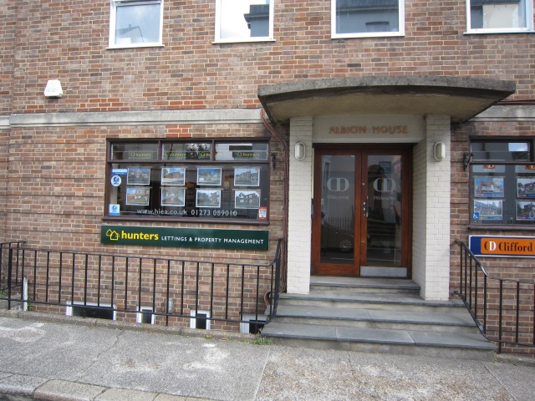
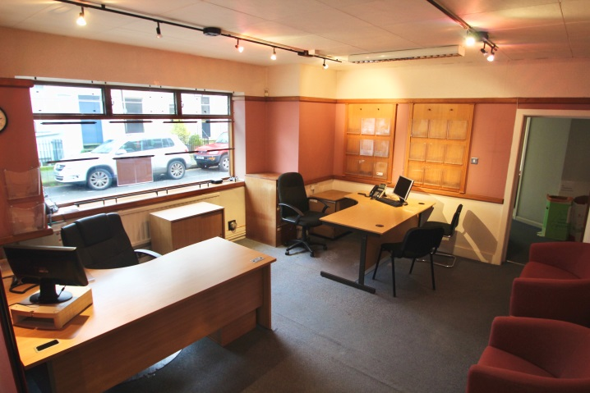

RATES
Please refer to the Local Authority for information on rates

LEGAL FEES
Each party to be responsible for their own legal costs.

ENERGY PERFORMANCE CERTIFICATE
Energy Performance Rating C.

VAT
We understand the property has not been elected for VAT.

TERMS
New lease to be agreed for a minimum of 12 months exclusive of rates but inclusive of service charge (heating, electricity, cleaning of common parts included). Rent is: Office 5 £490 with a car space : Room 4 £100; Room 1 £ 710 with a car space payable monthly in advance.

VIEWING
Jim Groves
Clifford Dann
Direct line: 01273 407920
jgroves@clifforddann.co.uk
In accordance with the Estate Agents (Provisions of Information) Regulations 1991 we inform you that a Member of this firm has an interest in the freehold of this property.Neither the Lessor nor the Agents gives or implies any warranty that the premises are fit for any particular use or that they comply with any relevant regulation or statutory requirement. The agents have not tested any apparatus, equipment, fittings or services so cannot verify that they are in working order. The tenant is advised to obtain verification from their Solicitor or Surveyor before proceeding.

CODE OF PRACTICE ON COMMERCIAL LEASES
Please be aware that the Code of Practice on Commercial Leases in England and Wales recommends you seek professional advice from a qualified surveyor, solicitor or licensed conveyancer before entering into or signing a business tenancy or lease agreement. The Code is available through professional institutions and trade associations or through the website www.commercialleasecodeew.co.uk

